DEPARTMENT OF PHYSICS
PANJAB UNIVERSITY
CHANDIGARH.

SIX-MONTHLY PROGRESS REPORT
PROFORMA FOR Ph.D. CANDIDATES
(To be submitted bi-annually by June, 30th and December, 31st )
(Please use extra sheet/s where required)

1. Name of the candidate: Anterpreet Kaur

2. Faculty : Science

3. Department : Physics

4. Enrollment No. and Date: 13/1033 , 10-04-2013

5. Registration No. and Date: N.A.

6. Tentative/Approved Title: Synopsis not submitted yet

7. A summary of the work done during the last six months (Depending upon the stage of Ph.D work) providing details of (i) Review of Literature, (ii)Experimentation/Data Collection, Field work (iii) Data Processing (iv) Data Analysis and Interpretation and (v) Stage of thesis writing with specific reference to the goals set for the previous 6 months. (Separate sheet attached)

8. Did you complete the tasks and achieve the goals you had set for the period under report? Yes

9. If Difficulties, Constraints faced in achieving the objectives that had been formulated for the period under report : No

10. If synopsis for Ph. D programme has not been submitted: Work to be undertaken
providing specific details (in quantifiable terms to the extent of the plan of work for the
next 6 months.

11. Publications if any : Yes "Subjet Multiplicities at LHC Energies and the QCD Color Factor
Ratio ," Advances in High Energy Physics, vol. 2013, Article ID 585809, 11 pages, 2013. doi:10.1155/2013/585809.
Certificate :

It is certified that the information provided above is correct to the best of my knowledge.
I shall try my best to achieve the above targets during the next six months.

Name of the Candidate: Anterpreet Kaur
Signature :

Certificate:
Progress report of the candidate:
Satisfactory/Unsatisfactory/Need to be improved

Supervisor Name: Prof. Manjit Kaur

Signature with date:

Counter –Signature of the Chairperson

NOTE: The Chairperson of the Department will place the six-monthly progress report so received before the joint meeting of the Administrative and Academic Committees of the Department within one month of their receipt. Chairperson will send the minutes and recommendations of the Committees to the Dean of University Instruction within a week’s time. In case of a candidate who does not submit the progress report within stipulated time, the Committees may recommend suitable action and repetition of such a practice might invite cancellation of his/her Ph. D. Registration.

PROGRESS REPORT (from 1.01.2014 to 30.06.2014)

PHYSICS PROBLEM

Quantum Chromodyanmics (QCD) is the one of the fundamental theory to describe strong interaction between quarks and gluons. In QCD, partons (quarks and gluons) are produced in hadron-hadron collision with huge cross sections. These partons get detected as spray of paricles called jets. The inclusive jet cross section measurements is one of the process by which QCD can be tested in hadron colliders. I will be studying the multijet cross-section ratios at center of mass energy of 8 TeV. Using the ntuples for center of mass energy of 8 TeV, provided by the SMP-J group, I have plotted the distributions of (pT,η,Φ) of leading jet in the events having at least 3 jets and also for those events having 4 jets. Jets are reconstructed using particle flow technique using the anti k_{T} clustering algorithm with size parameter R=0.7. I have applied cut on pT to be greater than 100 GeV to have high pT jets and jet tight id cut to have clean jets.The CMS trigger system is designed to control event rates.
It consists of two parts :
Level-1 Trigger(L1) : a hardware based trigger
High-Level Trigger(HLT) : a software based trigger.

In this physics problem, the trigger paths used are single jet triggers i.e. L1SingleJet and HLTJet which combinedly forms the HLTJet trigger path. The jets used in the trigger paths are corrected AK5 Particle Flow jets. The distributions are made after applying these triggers.

HARDWARE

I was deputed to CERN from 22nd January, 2014 to 19th April, 2014.
The Large Hadron Collider (LHC) is shutdown for upgradation in which the the proton beam energy will be increased from 4 TeV to 6.5 TeV per beam. During the upgradation, the Hybrid Photon Detectors (HPDs) of Outer Hadron calorimeter (HO) were to be placed by Silicon Photomultipliers (SiPMs). Hence, I participated in the installation of Readout Modules (RMs) with HPDs replaced by SiPMs in HO. The installation process took place for three weeks starting from March 24, 2014. I, along with the HO group, installed different RMs in Sectors YB+1 and YB+2 of HCAL.

SOFTWARE

- I participated in taking the runs for Quality Control Analysis in which various runs for e.g. LEDs, Peds, LED_PED_long etc. were taken by the HO group to analyse and studied various properties of SiPMs, now used in place of HPDs.

Study of properties of SiPMs with Time for different runs :

- I have studied the relative variation in Gain for PED runs with Time. I developed a code and made the plots to show the relative variation in Gain with Time for 18 channels and 92 RMs of six runs. The relative variation is calculated by the following formula by taking one run as refernce.

- Relative Gain = [Gain – Gain(Ref)]/[Gain(Ref)]

- This relative quantity for each RM is plotted on y-axis and different runs are taken on x-axis which represents time. The relative variation in Gain w.r.t. time in the following plot is less than 2%.
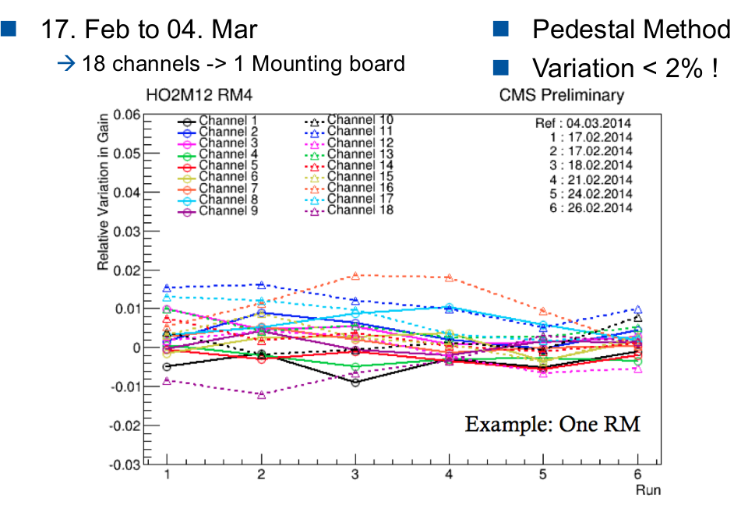

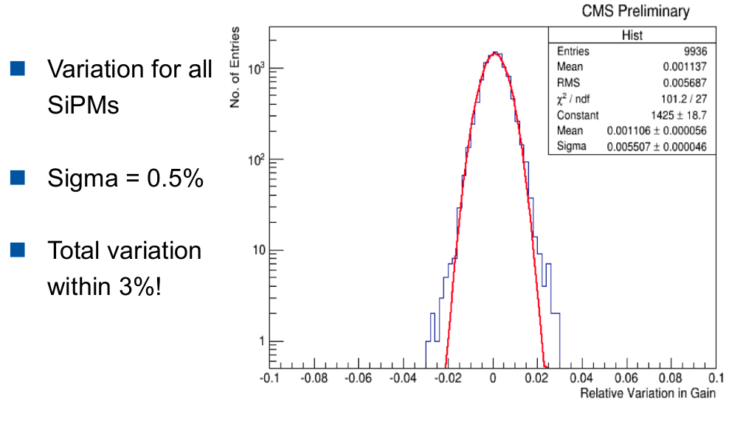
- I also made a distribution for relative variation in Gain for all the channels of all RMs and got a Gaussian distribution. The fitted distribution is shown as below. The plot shows the relative variation for all channels and RMs which is within 3%.
- In 16th International Conference on Calorimetry in High Energy Physics “CALOR 2014” at South Campus, Justus Liebeg University Giessen, Germany (6-11 April, 2014), these plots were presented under the title “MPPC Photon Sensor Operational Experience in CMS”.

Power Mezzanine testing

- With the increase in LHC Energy & luminosity large amount of data has to be processed. Number of channels will increase to store information of more depth in the detector. So, very high speed DAQ is needed. But the Current VME based system doesn't support data transfer rate which we will need after LS1 (Long Shutdown). So we need a μTCA based system which will lead to change of electronics.

- Power Mezzanine Testing program is designed to monitor or test μHTR Power Mezzanine (PM)
and Auxiliary Power Mezzanine (APM) for long term stability tests. We have installed a set-up
to test these mezzanines. Each test will be run on 5 mezzanines for 39 hrs. continuously. We have
tested one such set successfully.

Goals for the next six months :

- To study the pT spectrum of inclusive jets at 8 TeV in different rapidity bins and to compare the results with those from Monte Carlo Samples.

- To test the PM and APM mezzaninies for 39 hours per set.

- To work with the HO Upgrade group to study the stability and the Peltier behavior of the SiPMs after their installation.

- To attend various talks and lecture programs that would be helpful for my Ph.D degree.

ANTERPREET KAUR,
DEPARTMENT OF PHYSICS,
PANJAB UNIVERSITY, CHANDIGARH.

